A PROJECT TITLE

ON

Renewable Energy Output Prediction Using XGBoost and LightGBM

project report submitted in partial fulfilment of the requirements for the Course

MACHINE LEARNING

BACHELOR OF TECHNOLOGY

In

A.Y.: 2026-27

By

Jaswanth Reddy — 2520030284

Meghanadh Sai Reddy — 2520030274
Kunal — 2520030275

Under the Esteemed guidance of

Ravinder

Assistant Professor, CSE

Department of Computer Science and Engineering





Abstract
Renewable energy generation is strongly influenced by changing environmental and time-dependent conditions, making accurate prediction important for energy planning and efficient utilization of solar power. This project develops a supervised machine learning system for predicting solar AC power output using historical generation and weather sensor data. The study uses the Solar Power Generation Data dataset, containing generation records and weather observations collected at short time intervals.
The proposed workflow includes data inspection, cleaning, timestamp processing, exploratory data analysis, feature engineering, chronological train-test splitting, model training, and evaluation. XGBoost and LightGBM regression models are trained using ambient temperature, module temperature, solar irradiation, and engineered time features. The models are evaluated using Mean Absolute Error (MAE), Root Mean Square Error (RMSE), and R². In the reproduced experiment, LightGBM achieved MAE 36.9710, RMSE 121.1118 and R² 0.8641, while XGBoost achieved MAE 37.8787, RMSE 121.6129 and R² 0.8630. LightGBM therefore provided the best overall result in this experiment.
Keywords: Renewable Energy, Solar Power Prediction, Machine Learning, XGBoost, LightGBM, Regression

1. Introduction

1.1 Purpose of the Project
Solar power is a clean and increasingly important source of renewable energy. However, photovoltaic power output changes with solar irradiation, temperature, time of day and other environmental conditions. This variation makes planning and balancing solar generation more difficult. Accurate prediction can support energy scheduling, plant monitoring, grid integration and better utilization of renewable resources.
The purpose of this project is to build a practical machine learning solution that learns the relationship between weather conditions, time information and solar AC power generation. The project compares two efficient gradient-boosting methods, XGBoost and LightGBM, so that their prediction accuracy and practical performance can be evaluated using the same dataset and evaluation procedure.

1.2 Problem Statement
The project addresses a supervised regression problem in which historical solar-generation and weather-related features are used to predict continuous AC power output. The expected output is a numerical estimate of AC_POWER for a given set of environmental and time-based conditions. The primary objective is to obtain low prediction error and a high R² score while avoiding data leakage.

1.3 Existing Methods and Disadvantages
Traditional solar-power estimation may rely on physical equations, manual rules, historical averages or simple statistical models. These approaches can be useful, but they may not capture nonlinear relationships among irradiation, temperature and generation output. Their performance can also decrease when operating conditions change.
More complex machine learning and deep learning methods can model nonlinear behavior, but they may require more computational resources, larger datasets and longer training. The project therefore focuses on XGBoost and LightGBM because they provide strong nonlinear regression capability while remaining practical for a student-scale implementation.

1.4 Proposed System
The proposed system loads solar generation and weather data, validates and cleans the records, combines the relevant information, extracts time and cyclic features, and performs a chronological 80:20 train-test split. XGBoost and LightGBM regression models are then trained and evaluated using MAE, RMSE and R². The final system stores the processed dataset, trained models, predictions and visualizations for analysis and future deployment.

1.5 Research Objectives
- Prepare a suitable solar power generation dataset for the regression problem.
- Perform systematic data preprocessing and exploratory analysis.
- Engineer relevant time and weather features while preventing data leakage.
- Develop and train XGBoost and LightGBM regression models.
- Evaluate and compare both models using MAE, RMSE and R².
- Identify the better-performing model and discuss its practical applicability for renewable-energy planning.

2. Literature Survey (Recent Studies)
Recent research shows that machine learning is increasingly used for short-term photovoltaic power forecasting. The studies below were selected because they directly address photovoltaic prediction, gradient boosting, meteorological features or model comparison.
S.No. | Title | Reference with DOI | Problem / Gap | Objective | Methods | Inference | Future Research
1 | Photovoltaic Power Prediction Model Using Pre-train and Fine-tune Paradigm Based on LightGBM and XGBoost | Ye, Zhao & Deng (2023), Procedia Computer Science, 224, 407–412. DOI: 10.1016/j.procs.2023.09.056 | Different plants have different locations and environmental conditions. | Improve generalization across multiple PV plants. | Pre-training/fine-tuning with LightGBM and XGBoost. | Combining the two boosting approaches improved multi-plant prediction. | Test transfer learning across larger and more diverse plants.
2 | Short-Term Prediction of PV Power Based on Combined Modal Decomposition and NARX-LSTM-LightGBM | Gao et al. (2023), Sustainability, 15(10), 8266. DOI: 10.3390/su15108266 | PV output is nonlinear and intermittent. | Improve short-term forecasting accuracy. | Modal decomposition, NARX-LSTM and LightGBM. | Combining decomposition and boosting/deep learning can improve forecasts. | Explore lighter hybrid models for real-time use.
3 | Short-Term Photovoltaic Output Prediction Based on Decomposition and Reconstruction and XGBoost under Two Base Learners | Xu et al. (2024), Energies, 17(4), 906. DOI: 10.3390/en17040906 | High-frequency fluctuations make direct prediction difficult. | Improve tracking of short-term PV variations. | ICEEMDAN, Bagging, XGBoost and Sparrow Search optimization. | Decomposition plus optimized XGBoost improves short-term prediction. | Evaluate simpler versions with lower computational cost.
4 | Seasonal Short-Term Photovoltaic Power Prediction Based on GSK–BiGRU–XGboost Considering Correlation of Meteorological Factors | Xiong et al. (2024), Journal of Big Data, 11, 164. DOI: 10.1186/s40537-024-01037-x | PV characteristics change across seasons and weather conditions. | Use meteorological correlation and seasonal behavior to improve prediction. | Pearson correlation, BiGRU, XGBoost and GSK optimization. | Seasonal and correlation-aware models improve reliability. | Validate on additional climates and plant types.
5 | Prediction of Energy Production in a Building-Integrated Photovoltaic System Using Machine Learning Algorithms | Zoubir et al. (2024), Procedia Computer Science, 236, 75–82. DOI: 10.1016/j.procs.2024.05.007 | Building PV generation must be aligned with energy-management needs. | Predict hourly PV production from weather and time features. | Random Forest, Decision Tree, XGBoost, LightGBM and CatBoost. | LightGBM performed strongly among the compared models. | Evaluate additional building and climate conditions.
6 | Enhancing Photovoltaic Energy Forecasting with Machine Learning: A Comparison Study of XGBoost, LightGBM and LSTM Models | Vargas, Martinez & Loo (2024), IEEE LA-CCI. DOI: 10.1109/LA-CCI62337.2024.10814763 | Different ML models show different forecasting behavior. | Compare XGBoost, LightGBM and LSTM for PV forecasting. | XGBoost, LightGBM and LSTM with MSE, RMSE, MAE and R². | XGBoost was reported as the most accurate among the compared models. | Investigate hybrid methods and parameter optimization.
7 | Enhanced Short-Term Photovoltaic Power Prediction Using a Hybrid Improved Whale Optimization Algorithm with XGBoost | Subramani et al. (2024), IEEE SPECon. DOI: 10.1109/SPECon61254.2024.10537570 | PV volatility creates difficulty for grid management. | Improve XGBoost-based short-term prediction. | Improved Whale Optimization Algorithm with XGBoost. | Optimization can improve the forecasting behavior of XGBoost. | Study computationally lighter optimization strategies.
8 | Forecasting Rooftop Photovoltaic Solar Power Using Machine Learning Techniques | Singh et al. (2025), Energy Reports, 13, 3616–3630. DOI: 10.1016/j.egyr.2025.03.005 | Small rooftop datasets make accurate PV forecasting challenging. | Compare ML techniques for rooftop PV forecasting. | Multiple ML models including XGBoost with error metrics. | XGBoost achieved strong forecasting performance in the study. | Validate across more rooftop installations.
9 | WBML-PV: Window-Based Machine Learning for Ultra-Short-Term Photovoltaic Power Forecasting | Naqvi, Chong & Tayara (2025), IFAC Journal of Systems and Control, 34, 100342. DOI: 10.1016/j.ifacsc.2025.100342 | Ultra-short-term forecasts require fast and accurate models. | Improve forecasting accuracy and computational efficiency. | Window-based LightGBM and XGBoost with uncertainty quantification. | Window-based models improved forecasting and training efficiency. | Extend uncertainty methods to more operating scenarios.
10 | Physics-Informed Voting Ensemble for Solar Power Generation Forecasting: Integrating Domain Knowledge with Machine Learning | Naghapushanam, Jeevarathinam & Sankari (2026), Energy Informatics, 9, 3. DOI: 10.1186/s42162-025-00604-7 | Pure data-driven models may miss physical solar relationships. | Combine domain knowledge with ML for robust forecasting. | Physics-informed features with Gradient Boosting, LightGBM and XGBoost ensemble. | Physics-informed ensemble achieved strong forecasting performance. | Investigate real-time deployment and external validation.

3. Methodology

3.1 Proposed System Flow Diagram
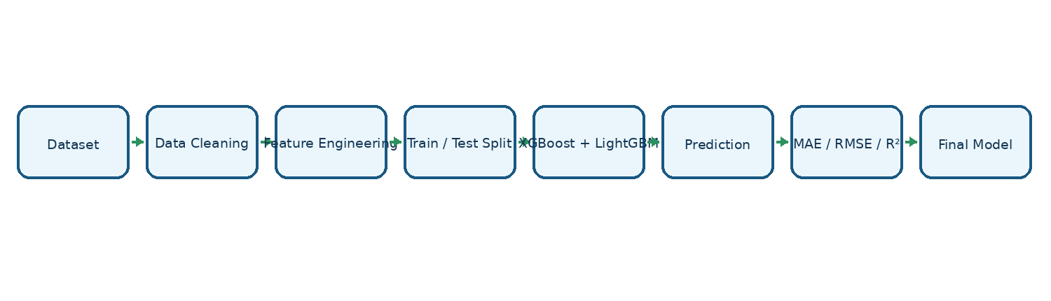
Figure 1. Proposed system workflow for renewable energy output prediction.

3.2 Dataset Description
The project uses the Kaggle Solar Power Generation Data dataset, which contains solar generation records and weather sensor measurements collected at short time intervals from two solar plants. The generation data include DATE_TIME, PLANT_ID, SOURCE_KEY, DC_POWER, AC_POWER, DAILY_YIELD and TOTAL_YIELD. The weather data include DATE_TIME, PLANT_ID, SOURCE_KEY, AMBIENT_TEMPERATURE, MODULE_TEMPERATURE and IRRADIATION. The prediction target is AC_POWER. The final modeling features are ambient temperature, module temperature, irradiation and engineered time features such as hour, minute, day, month, day of week, hour sine and hour cosine.

3.3 Experimental Setup
The implementation is developed in Python using a Windows environment and can be executed from VS Code, Jupyter Notebook or a terminal. The main libraries are Pandas, NumPy, Matplotlib, Scikit-learn, XGBoost, LightGBM and Joblib. Streamlit is included for the optional prediction interface. The project uses a chronological 80:20 train-test split so that later observations are not used to train the model before they occur.

3.4 Data Preprocessing
- Loaded generation and weather CSV files and inspected their schemas.
- Converted DATE_TIME to a datetime representation.
- Converted relevant numerical columns to numeric types.
- Merged generation and weather information using DATE_TIME and PLANT_ID.
- Removed duplicate records and rows with missing required modeling values.
- Removed invalid negative AC_POWER values.
- Excluded DC_POWER, DAILY_YIELD and TOTAL_YIELD from predictors because they can cause target leakage when predicting AC_POWER.
- Used a chronological train-test split to reduce temporal leakage.

3.5 Exploratory Data Analysis
EDA was performed to understand the time pattern of power generation, the relationship between irradiation and AC power, the relationship between temperature and AC power, and correlations among numerical variables.
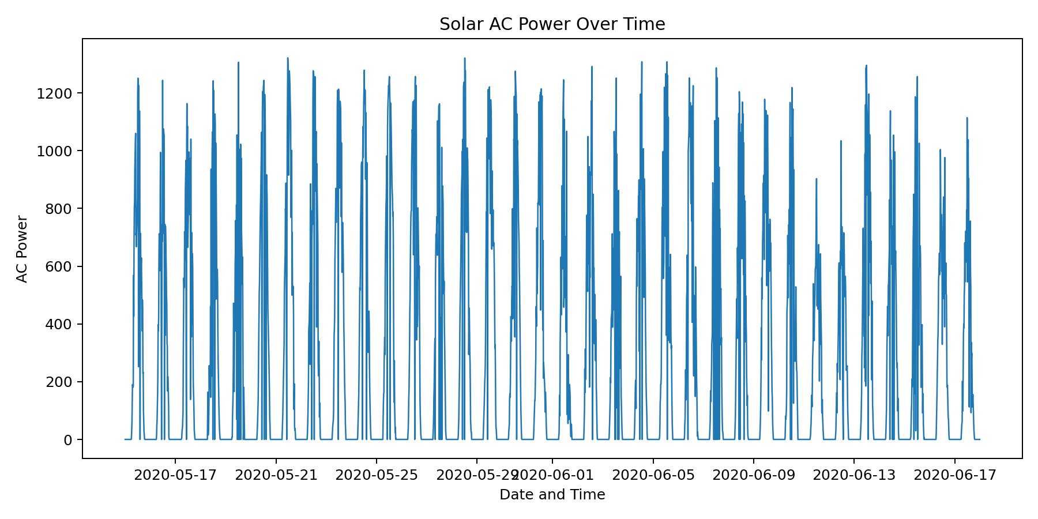
Figure 2. Solar AC power variation over time.
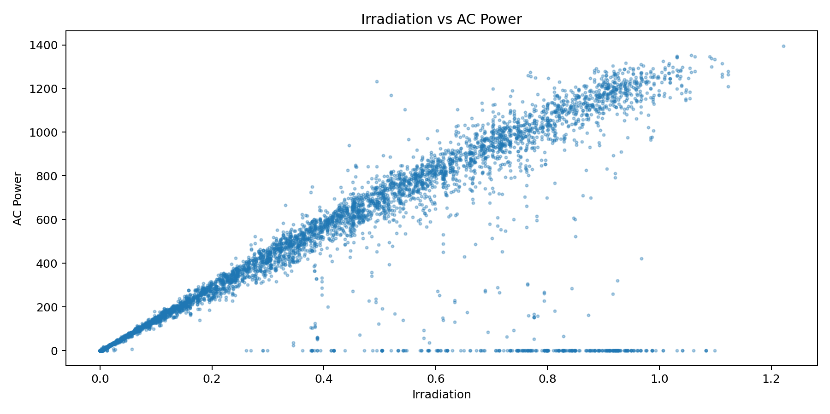
Figure 3. Relationship between irradiation and AC power.
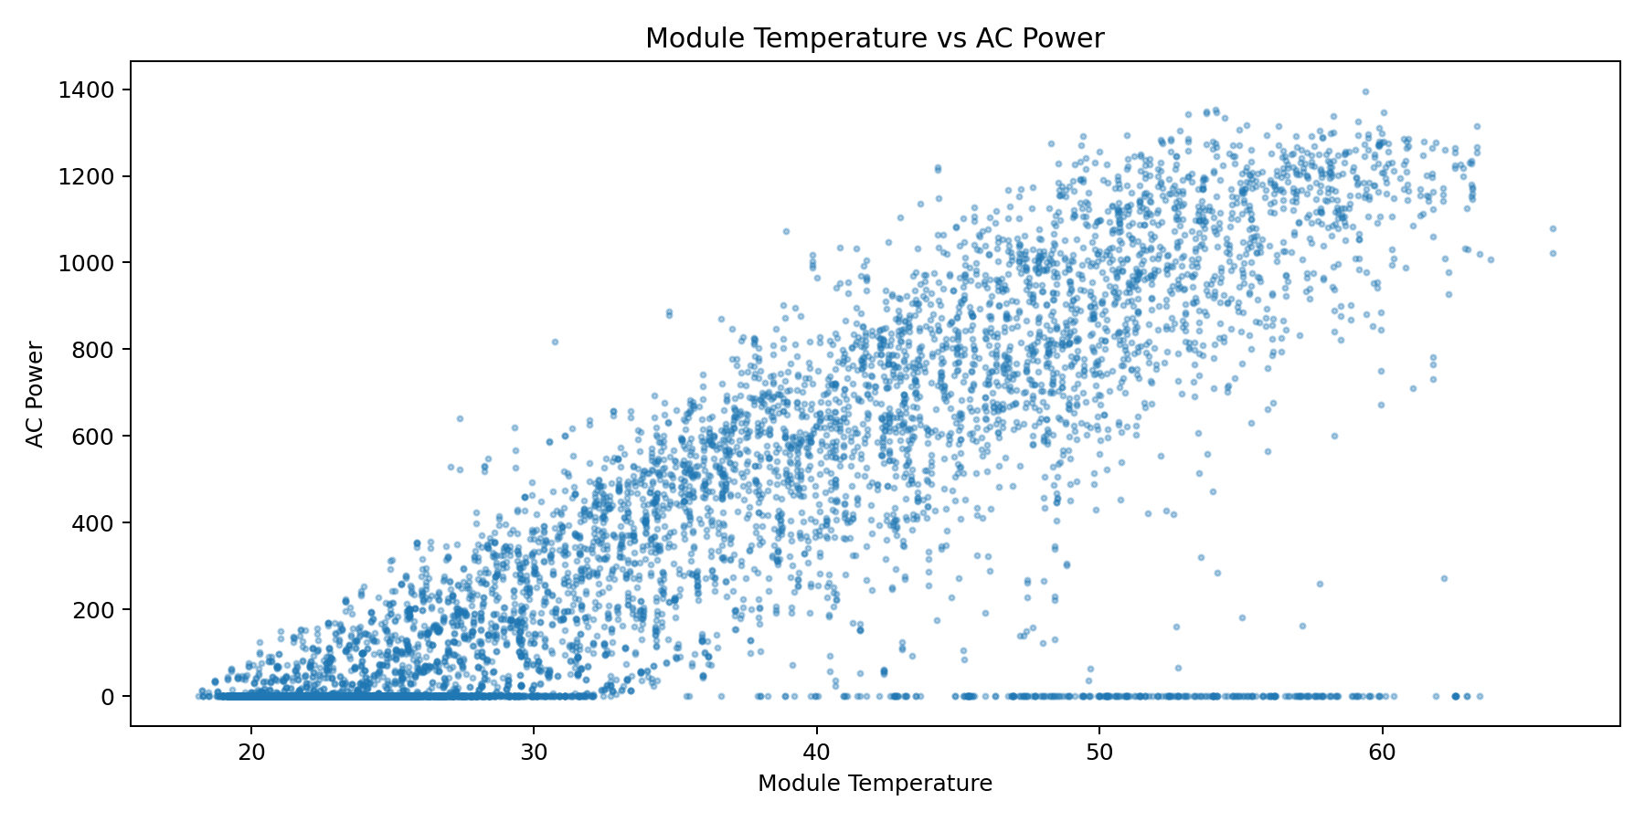
Figure 4. Temperature and AC power relationship.
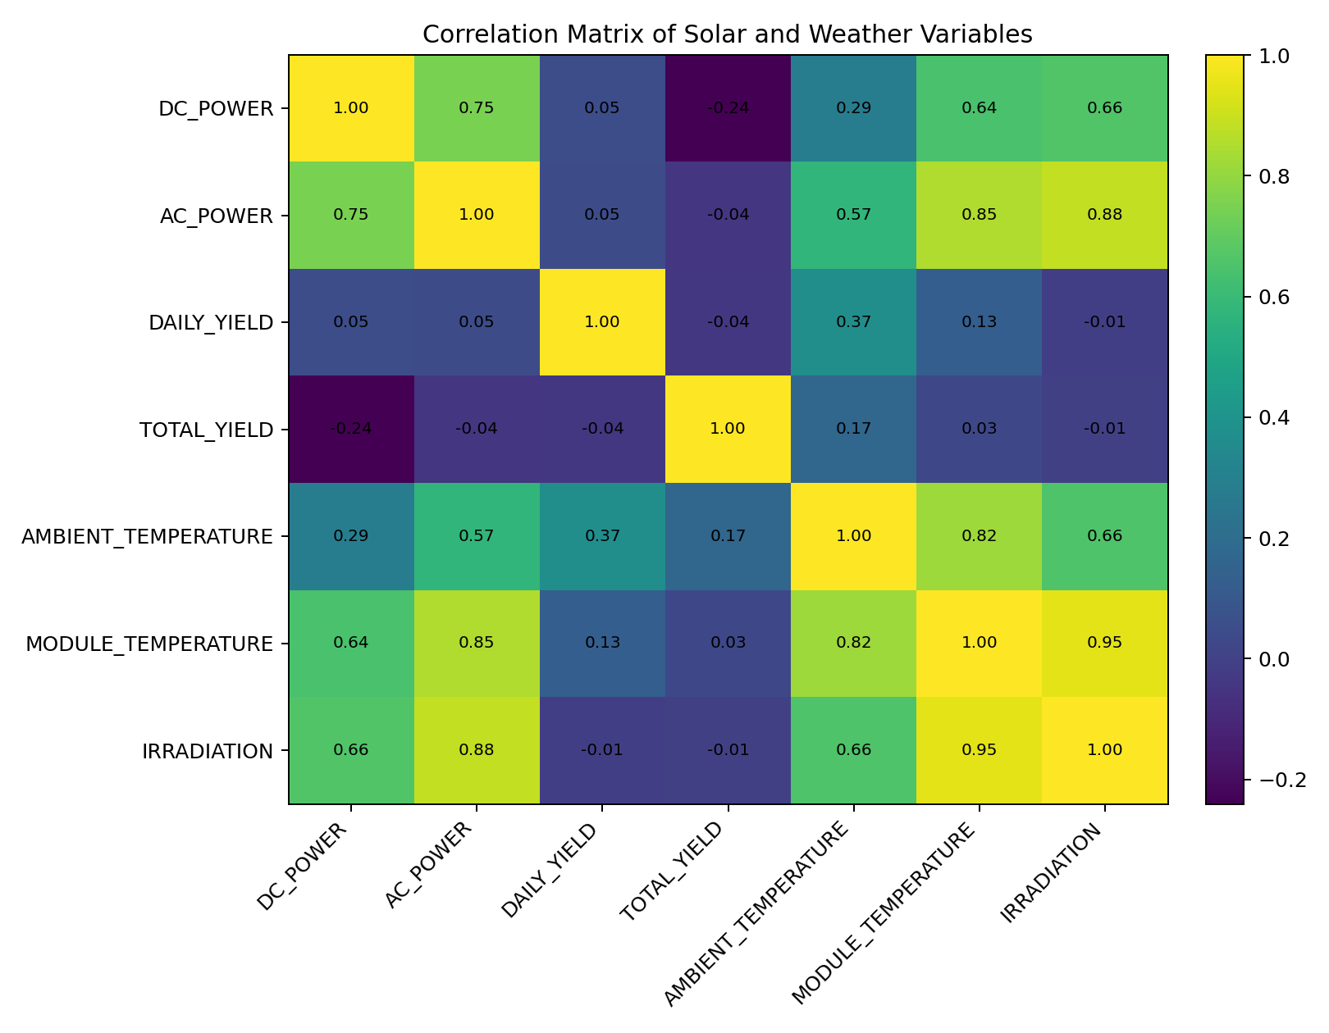
Figure 5. Correlation heatmap of the project variables.

3.6 Feature Engineering and Feature Selection
Time information was extracted from DATE_TIME to represent temporal behavior. The model uses HOUR, MINUTE, DAY, MONTH and DAY_OF_WEEK. HOUR_SIN and HOUR_COS were also generated to represent the cyclic nature of time. The final feature set contains 10 predictors: AMBIENT_TEMPERATURE, MODULE_TEMPERATURE, IRRADIATION, HOUR, MINUTE, DAY, MONTH, DAY_OF_WEEK, HOUR_SIN and HOUR_COS.

3.7 Model Building and Training
Two supervised regression algorithms were implemented. XGBoost is an optimized gradient-boosting tree method that builds trees sequentially to reduce prediction error. LightGBM is another gradient-boosting tree method designed for efficient training and good predictive performance. Both models were trained using the same engineered feature set and chronological train-test split.
XGBoost configuration: n_estimators=300, learning_rate=0.05, max_depth=6, subsample=0.90, colsample_bytree=0.90.
LightGBM configuration: n_estimators=300, learning_rate=0.05, num_leaves=31, subsample=0.90, colsample_bytree=0.90.

3.8 Hyperparameter Tuning
The current project uses fixed model parameters selected for a practical baseline comparison rather than an exhaustive GridSearchCV or RandomizedSearchCV experiment. Therefore, the reported results should be described as a controlled model comparison, not as the result of a full hyperparameter optimization study.

3.9 Model Evaluation
Because AC_POWER is a continuous numerical target, this project is a regression task. MAE measures the average absolute prediction error, RMSE gives greater weight to larger errors, and R² measures the proportion of target variance explained by the model. Lower MAE and RMSE are better, while higher R² is better. A conventional confusion matrix is not used because it is primarily a classification evaluation tool.

4. Results and Discussion

4.1 Preprocessing Results
After preprocessing, the dataset was converted into a consistent numerical modeling format. Timestamp values were parsed, required numerical fields were cleaned, invalid negative target values were removed, and time-based features were generated. The final model uses 10 predictors and AC_POWER as the target. A chronological 80:20 split was used for final evaluation.

4.2 Model Performance
Model | MAE | RMSE | R²
XGBoost | 37.8787 | 121.6129 | 0.8630
LightGBM | 36.9710 | 121.1118 | 0.8641
LightGBM achieved the best result in the reproduced experiment, with the lowest MAE and RMSE and the highest R². The difference is small, which indicates that both gradient-boosting models learned the solar generation pattern reasonably well.

4.3 Visual Results and Discussion
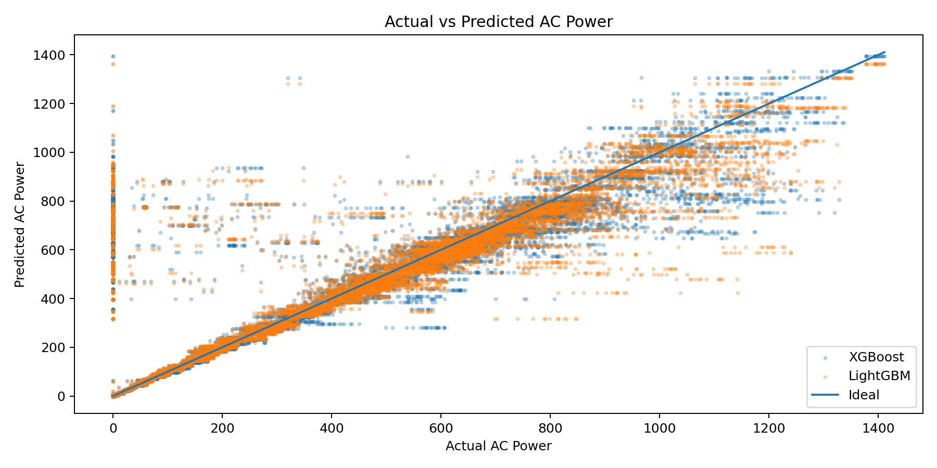
Figure 6. Actual versus predicted AC power.
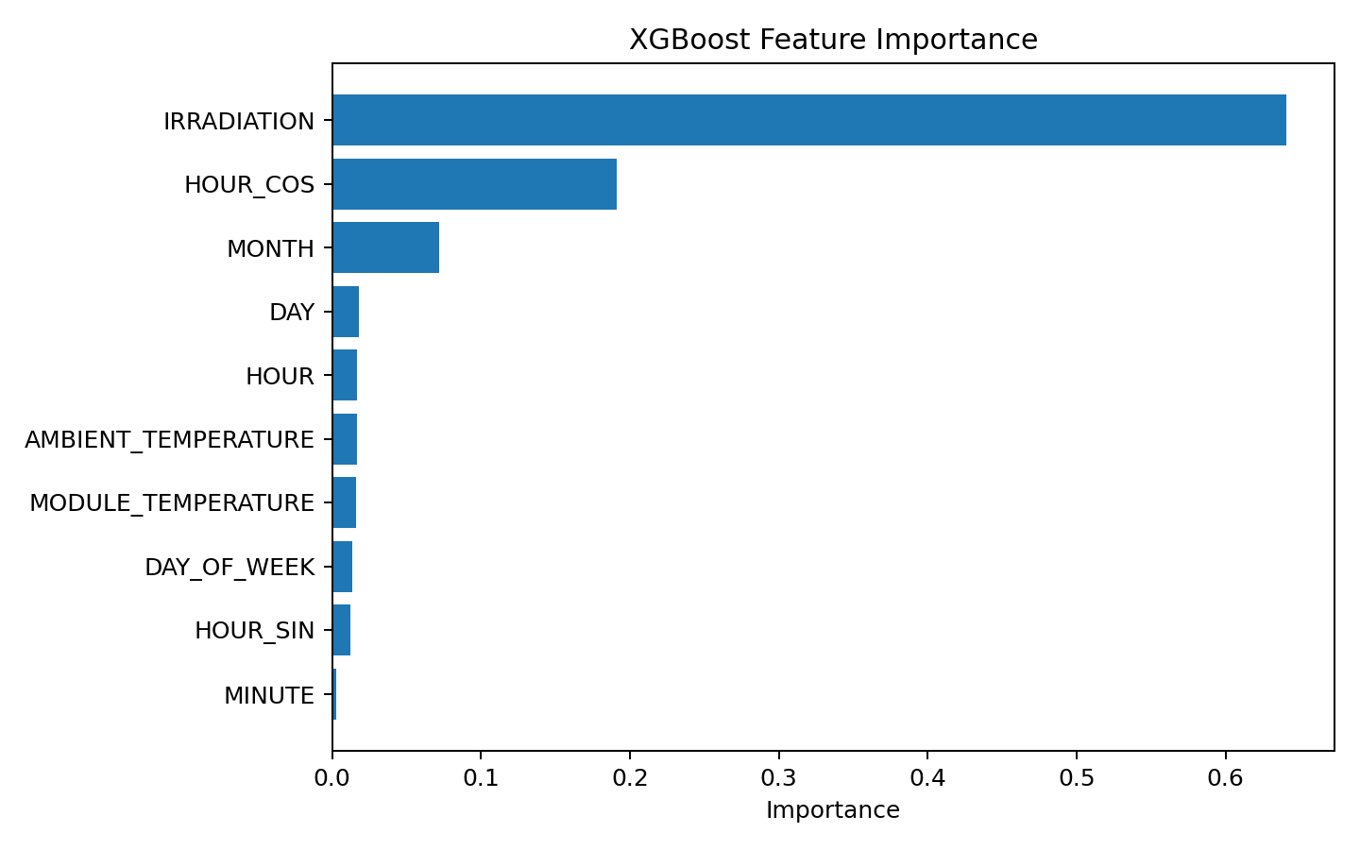
Figure 7. XGBoost feature importance.
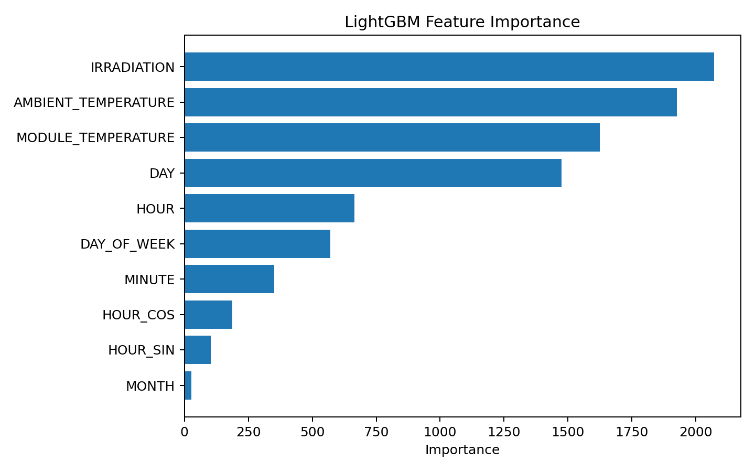
Figure 8. LightGBM feature importance.
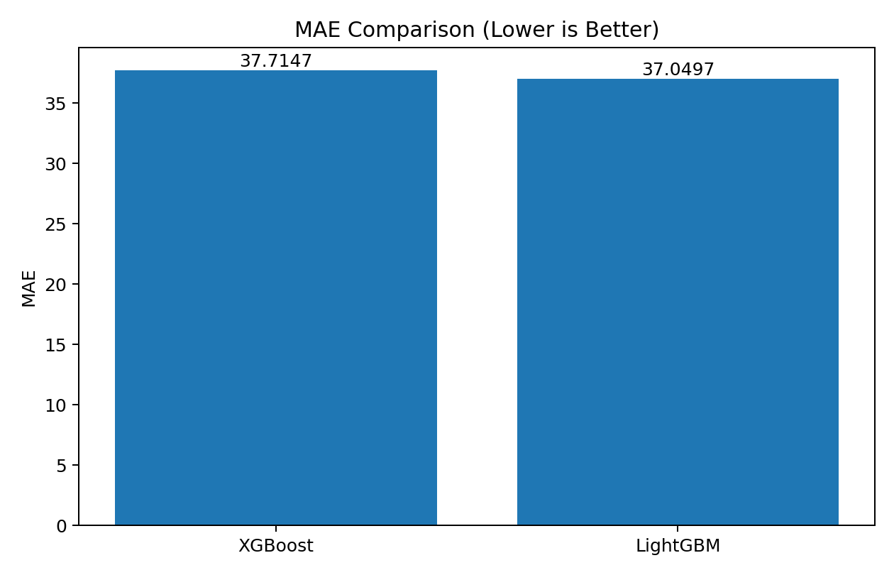
Figure 9. MAE comparison.
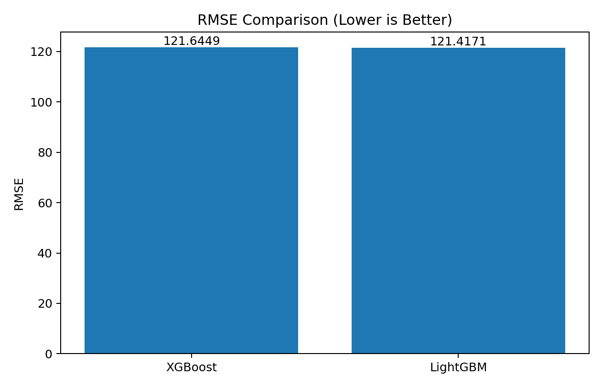
Figure 10. RMSE comparison.
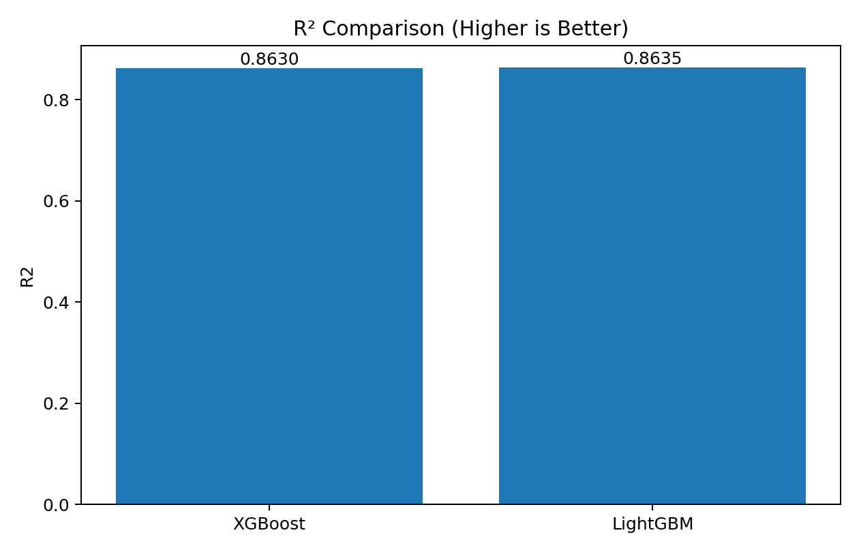
Figure 11. R² comparison.
The actual-versus-predicted plot provides a direct visual check of regression behavior. The feature-importance plots help identify which engineered inputs contribute most to model decisions. The metric comparison graphs show that LightGBM slightly outperformed XGBoost on all three reported metrics in this experiment. Since the project uses a single dataset and a chronological holdout, the results should be interpreted as an experimental comparison rather than a universal claim that one algorithm is always superior.

5. Conclusion
This project developed a machine learning system for renewable energy output prediction using solar generation and weather sensor data. The workflow covered preprocessing, exploratory analysis, time-based feature engineering, XGBoost and LightGBM model training, and regression evaluation. The target variable was AC_POWER, and the evaluation used MAE, RMSE and R².
In the reproduced experiment, LightGBM provided the best overall performance with MAE 36.9710, RMSE 121.1118 and R² 0.8641, while XGBoost achieved MAE 37.8787, RMSE 121.6129 and R² 0.8630. The results demonstrate that gradient boosting models can effectively learn relationships between solar irradiation, temperature, time and renewable energy output.

6. Future Work
- Use larger and more diverse solar and weather datasets from different geographic regions.
- Perform systematic hyperparameter optimization using GridSearchCV, RandomizedSearchCV or Bayesian optimization.
- Evaluate additional algorithms such as Random Forest, CatBoost, LSTM and hybrid ensembles.
- Add uncertainty estimation and prediction intervals for operational decision-making.
- Investigate explainable AI methods such as SHAP to interpret individual predictions.
- Develop a real-time web or cloud deployment connected to live weather and plant data.
- Validate the trained models on an external dataset to measure generalization.
- Monitor model drift as weather, equipment and plant operating conditions change.

7. References
[1] J. Ye, B. Zhao, and H. Deng, “Photovoltaic Power Prediction Model Using Pre-train and Fine-tune Paradigm Based on LightGBM and XGBoost,” Procedia Computer Science, vol. 224, pp. 407–412, 2023. doi: 10.1016/j.procs.2023.09.056.
[2] Gao et al., “Short-Term Prediction of PV Power Based on Combined Modal Decomposition and NARX-LSTM-LightGBM,” Sustainability, vol. 15, no. 10, 8266, 2023. doi: 10.3390/su15108266.
[3] Xu et al., “Short-Term Photovoltaic Output Prediction Based on Decomposition and Reconstruction and XGBoost under Two Base Learners,” Energies, vol. 17, no. 4, 906, 2024. doi: 10.3390/en17040906.
[4] Xiong et al., “Seasonal short-term photovoltaic power prediction based on GSK–BiGRU–XGboost considering correlation of meteorological factors,” Journal of Big Data, vol. 11, 164, 2024. doi: 10.1186/s40537-024-01037-x.
[5] Zoubir et al., “Prediction of energy production in a building-integrated photovoltaic system using machine learning algorithms,” Procedia Computer Science, vol. 236, pp. 75–82, 2024. doi: 10.1016/j.procs.2024.05.007.
[6] J. Vargas, R. Martínez, and L. Loo, “Enhancing Photovoltaic Energy Forecasting with Machine Learning: A Comparison Study of XGBoost, LightGBM and LSTM Models,” IEEE LA-CCI, 2024. doi: 10.1109/LA-CCI62337.2024.10814763.
[7] Subramani et al., “Enhanced Short-Term Photovoltaic Power Prediction using a Hybrid Improved Whale Optimization Algorithm with XGBoost,” IEEE SPECon, 2024. doi: 10.1109/SPECon61254.2024.10537570.
[8] U. Singh, S. Singh, S. Gupta, M. A. Alotaibi, and H. Malik, “Forecasting rooftop photovoltaic solar power using machine learning techniques,” Energy Reports, vol. 13, pp. 3616–3630, 2025. doi: 10.1016/j.egyr.2025.03.005.
[9] S. K. H. Naqvi, K. T. Chong, and H. Tayara, “WBML-PV: Window-based machine learning for ultra-short-term photovoltaic power forecasting,” IFAC Journal of Systems and Control, vol. 34, article 100342, 2025. doi: 10.1016/j.ifacsc.2025.100342.
[10] Naghapushanam, Jeevarathinam, and Sankari, “Physics-informed voting ensemble for solar power generation forecasting: integrating domain knowledge with machine learning,” Energy Informatics, vol. 9, 3, 2026. doi: 10.1186/s42162-025-00604-7.
[11] Kaggle, “Solar Power Generation Data,” dataset by Anikannal. https://www.kaggle.com/datasets/anikannal/solar-power-generation-data

Appendix: Project Structure and Execution
Project structure:
- dataset/raw/ — original generation and weather CSV files
- dataset/processed/ — cleaned and feature-engineered data
- notebooks/ — EDA, preprocessing, feature engineering and model notebooks
- src/ — preprocessing, feature engineering, XGBoost, LightGBM and evaluation modules
- models/ — trained model files
- results/ — graphs, metrics, predictions and correlation matrix
- app/ — Streamlit prediction interface
- main.py — complete training and evaluation pipeline
Main execution commands:
py -m pip install -r requirements.txt
py main.py
streamlit run app\app.py

